

Air University Multan Campus

Department of Computer Science and Engineering

Project Name:

Calculator in Python

**Mid Term Exam**

Prepared by

|  |  |
| --- | --- |
| **Group#: 07** | **Grade:** 6th |
| **Group Email:** 183179@students.au.edu.pk | |
| **Group members: 07** | |
| ***<Student1, ID ,Role>*** | 183179 |
| ***<Student2, ID, Role>*** | 183187 |
| ***<Student3, ID, Role>*** | 183201 |
| ***<Student4, ID, Role>*** | 183223 |
| ***<Student5, ID, Role>*** | 183189 |

**Supervised by**

Ma'm Atka Ali

<6thSemester> <1442>

<Spring> <2021>

**Revision Table**

|  |  |  |  |
| --- | --- | --- | --- |
| **Page#** | **Section#** | **Reviewer** | **Corrected by (Reviewer, Author)** |
|  |  |  |  |
|  |  |  |  |
|  |  |  |  |
|  |  |  |  |
|  |  |  |  |
|  |  |  |  |
|  |  |  |  |

**Table of Contents**

1. Introduction 4

2. Instructions 5

3 The problem 6

4 Project Scope 6

5 Hardware and Software Tools 6

6 Roles and Responsibilities 6

7 References 7

* **Introduction**

We have created a Django based calculator app. We have used Bootstrap, HTML, CSS. The calculator performs different operations like Add, Subtract, Multiplication, Divide, Floor Division. It is easy to understand and have simple user interface.

**Input:**

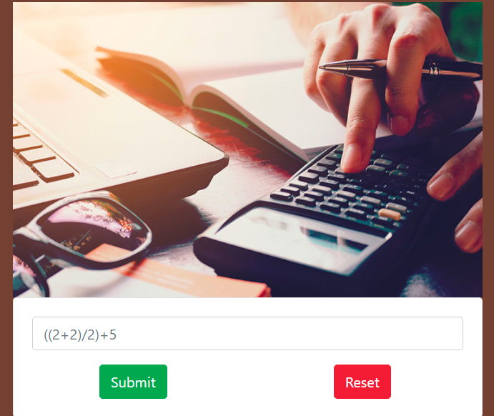

This is the input page where you have to input the numbers and get the result. You have the input the digit and submit it to get the result. Suppose if we input a character or any letter it gives an error.

**Instructions:** 

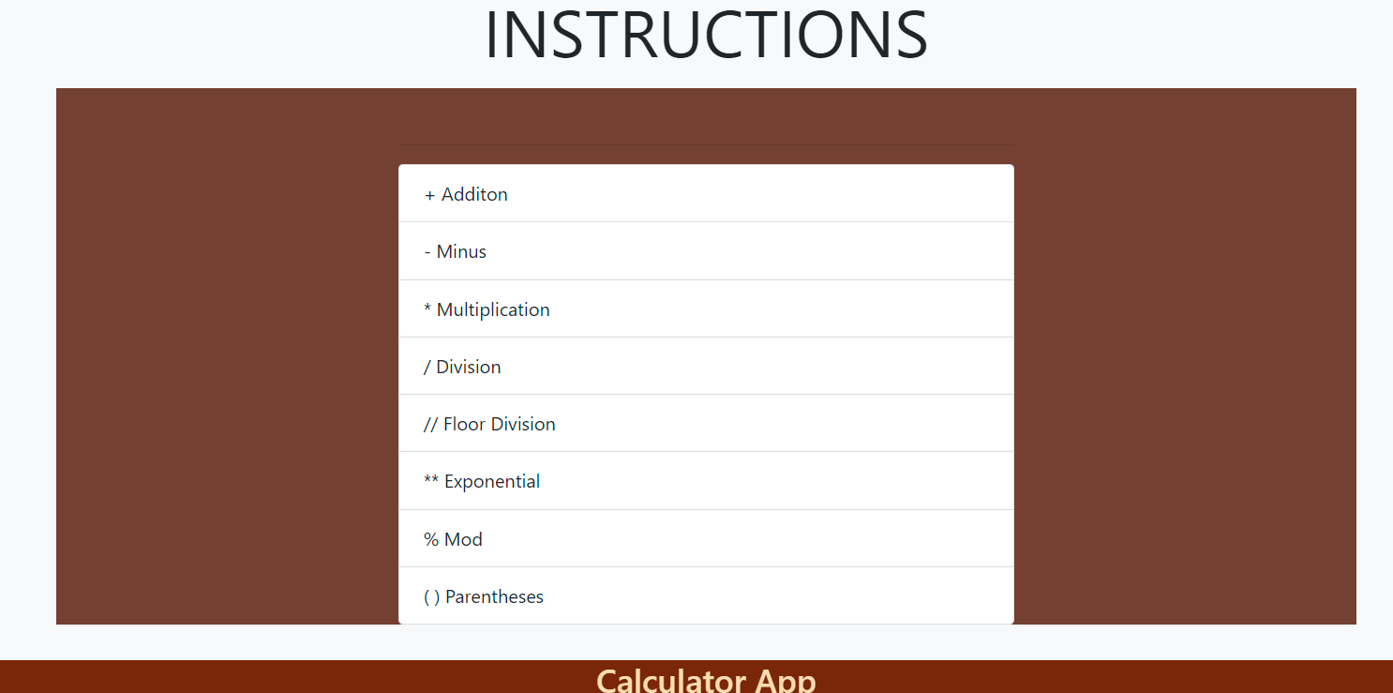

This is the instruction page where these operations are performed. Django calculator is the header of this app and Calculator app is the footer.

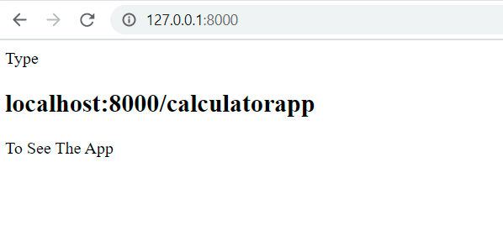

We add a new operation in our app is that if you forgot the name of the app it can’t give you an error. Even it shows you the link that you have write to see the app.

* **The Problem**

The main problem is that how we can add different operations of calculator by using Django. The system must give an error if anyone input character.

* **Project Scope**

The scope of the project is to provide a simple calculator by using Django. It can perform all the operations which we use in daily life. We are trying to make an app which helps people to understand easily.

* **Hardware and Software Tools**

6.1.Hardware

6.2.Software

* **Roles and Responsibilities**

Roles and responsibilities of project members should be clearly stated in the beginning of the project.

The following table can be used as a template:

|  |  |  |
| --- | --- | --- |
| **Role** | **Responsibilities** | **Participant(s)** |
| **Project Leader** | lead everyone in project | M.Saeed Tariq |
| **Analysis** | Analyze the project | Muhammad Haris |
| **Design** | Designing the layout | M.Umair Awan |
| **Implementation** | Implement the project | M. Muneeb |
| **Testing** | Testing the project | Talha Ahmad |

**References**

<https://github.com/UmairAwan25/Midterm_exam_group7>

This is the github link where you have to download the zip file of this app.

<http://127.0.0.1:8000/calculatorappsubmitquery?query=a-s#instructions>